Student’s name | …………………………………………………….…… | Grade | 4
Subject | Computer | Week No. | 8
Lesson Title | Presentation | Unit
Worksheet No. ( 8 ) (Answer)

Question A: Write the correct name of each part.

Quick access toolbar | Titlebar | Ribbon Menu

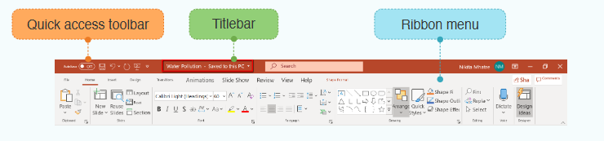
Quick access toolbar
Titlebar
Ribbon Menu

Good Luck

